**Course Name: Analog Communication**

**MATLAB Experiment-3**

**Objective** – Write MATLAB code to study *exponential* *Fourier series* representation

of a *saw tooth wave* with fundamental period 2 and amplitude changes -1 to 1 during the period. Plot the Fourier series representation for n = 1, 10, 20 and 50 and

comment on the plots by comparing with the original function. Also, find

difference with original function and explain Gibbs Phenomena.

**MATLAB Code**:

syms t n

w0=pi;

t0=2; % fundamental timeperiod = 2

n=1:100;

t1=0:.01:10;

a0=(1/t0)*int((t-1),t,-1,1);

an=(2/t0)*int((t-1)*(exp(-sqrt(-1)*n*w0*t)),t,0,2);

% int stands for integration

%here a0,an are fourier coefficients

y = sawtooth(pi*t1); %sawtooth wave

m=1;

for r=[1 10 20 50]

sum=0;

for j=1:1:r

sum=sum+(an(j))*exp(sqrt(-1)*w0*n(j)*t1);

end

subplot(2,4,m);

m=m+1;

plot(t1,sum,t1,y);

xlabel('time');

ylabel('Sum');

legend('Fourier Series', 'Sawtooth Wave');

subplot(2,4,m);

m=m+1;

plot(t1,sum-y);

xlabel('time');

ylabel('Difference');

legend('Gibbs Phenomena');

end

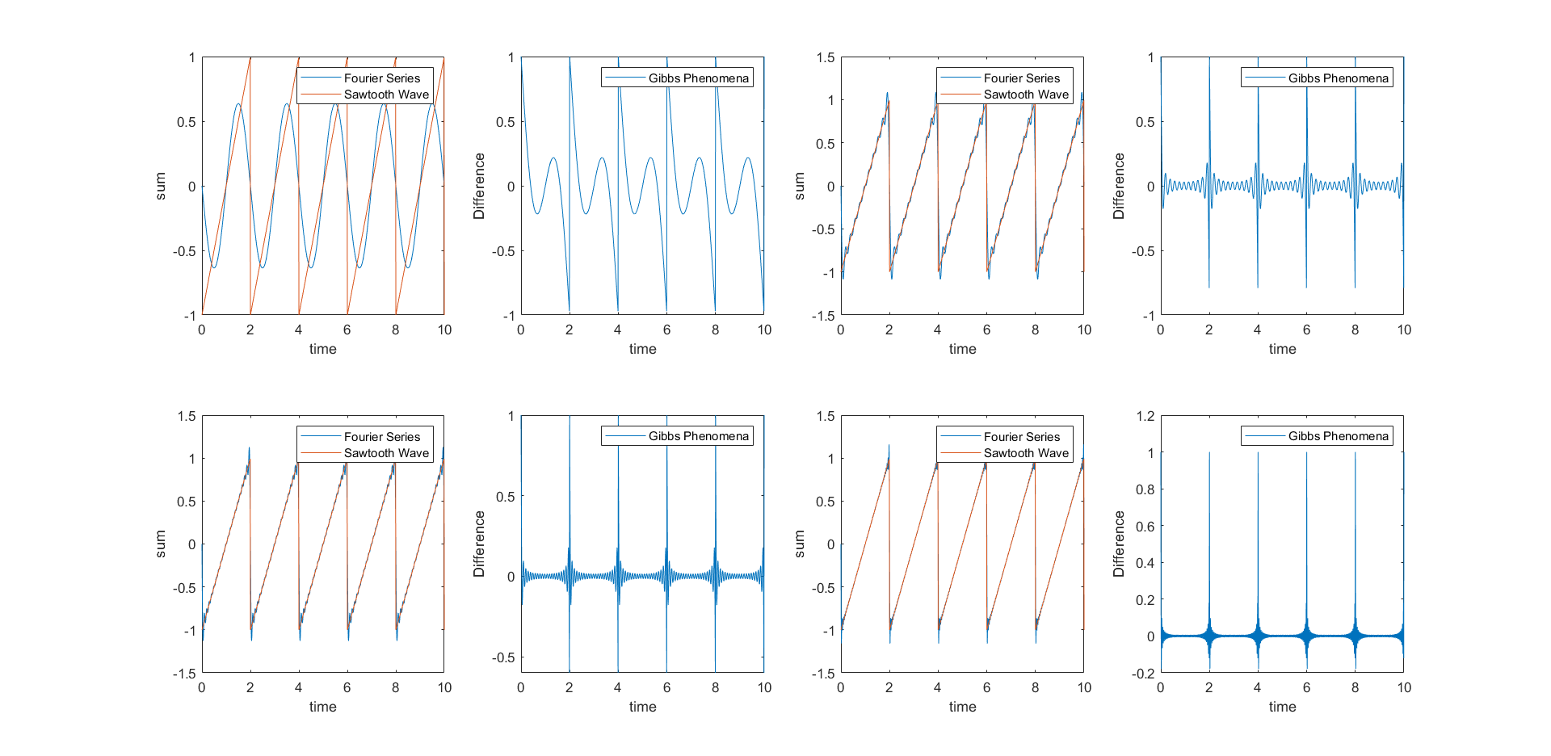**Results:** Result obtain by the code